* **First create table Olympic_data using create command with name,age,country,year,closing_date,sport,gold_medal,silver_medal ,bronze medal and total as columns.**

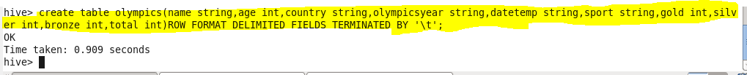

* **We can check our table if created or not using show tables.**

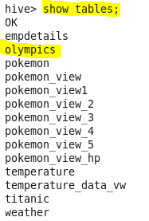

* **Now load our dataset Olympic_data.csv using LOAD command**

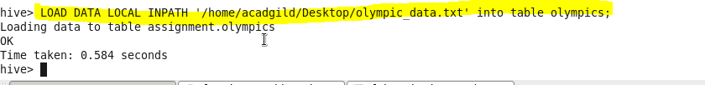

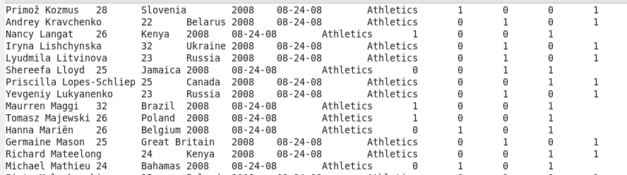

* **Write a Hive program to find the number of medals won by each country in swimming.**

Since we want the number of medals won by each country in swimming hence we will group by country and filtered by swimming using where condition

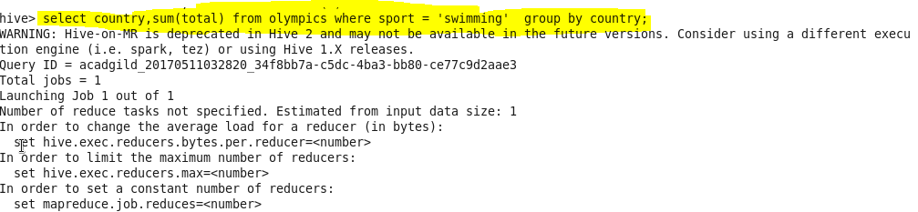

**Output:-**

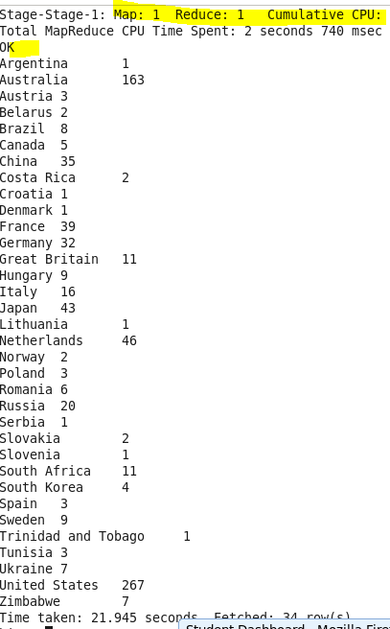

* **Write a Hive program to find the number of medals that India won year wise**

Since we want medal won by India year wise group result by year and filter by country equal to india using where condition.

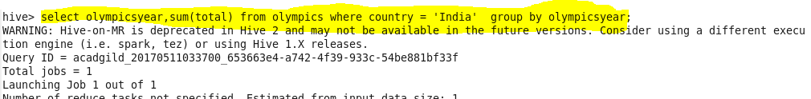

**Output:-**

